Stem Cells: Supercharging Cells Help Transplant Patients
Kathleen Lees k.lees@scienceworldreport.com First Posted: Jul 03, 2015 08:01 PM EDT

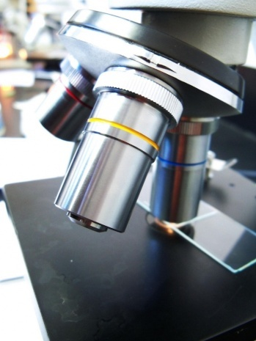
Stem Cells: Supercharging Cells Help Transplant Patients (not pictured here) (Photo : Kiran Foster)
Researchers at the University of Adelaide have discovered promising signs in stem cell therapy that may be effective in preventing and treating inflammation via transplant recipients. The findings are published in the journalStem Cells, which are expected to eventually lead to new treatments for transplant patients.
Researchers noted that stem cell therapy was proven effective in the treatment of stem cells for preventing and treating inflammation in transplant patients, particularly for controlling rejection.
Stem cell therapy is showing promising signs for transplant patients and according to researchers, the IL-17 treated stem cells should be even more effective at preventing and treating inflammation in transplant recipients -- particularly for controlling rejection, and researchers are hopeful that the study results could bring an exciting breakthrough in stem cell research for those in need.
"Adult mesenchymal stem cells, which can be obtained from many tissues in the body including bone marrow, are fascinating scientists around the world because of their therapeutic nature and ability to cultivate quickly. These stem cells have been used for the treatment of many inflammatory diseases but we are always looking for ways in which to increase stem cells' potency," lead study author Kisha Sivanathan, a PhD student in the University of Adelaide's School of Medicine and the Renal Transplant Unit at the Royal Adelaide Hospital, said in a news release. "We discovered that when cultured mesenchymal stem cells are treated with IL-17 they grow twice as fast as the untreated stem cells and are more efficient at regulating the body's immune response."
"Current drugs (immunosuppressant drugs) used to help prevent a patient rejecting a transplant suppress the whole immune system and can cause severe side effects, like cancer. However, stem cell therapy (used in conjunction with immunosuppressant drugs) helps patients 'accept' transplants while repairing damaged tissue in the body, resulting in less side effects," she added.
Though the researchers have yet to undertake clinical trials with IL-17 treated stem cells, they hope that the treatment produces more potent stem cells that help in preventing rejection in transplant patients.

